JAVA Assingment – 01

Last Date of submission :- 01-09-23

1. To print an integer entered by the user:
2. import java.util.Scanner;
3. public class integer {
4. public static void main(String args[]) {
5. System.out.print("KRISHNA JAISWAL \nROLL NO. 0827CI221076\n");
6. System.out.println("Enter any integer");
7. try (Scanner sc = new Scanner(System.in)) {
8. int integer = sc.nextInt();
9. System.out.println("The entered integer is: " + integer);
10. }
11. }
12. }

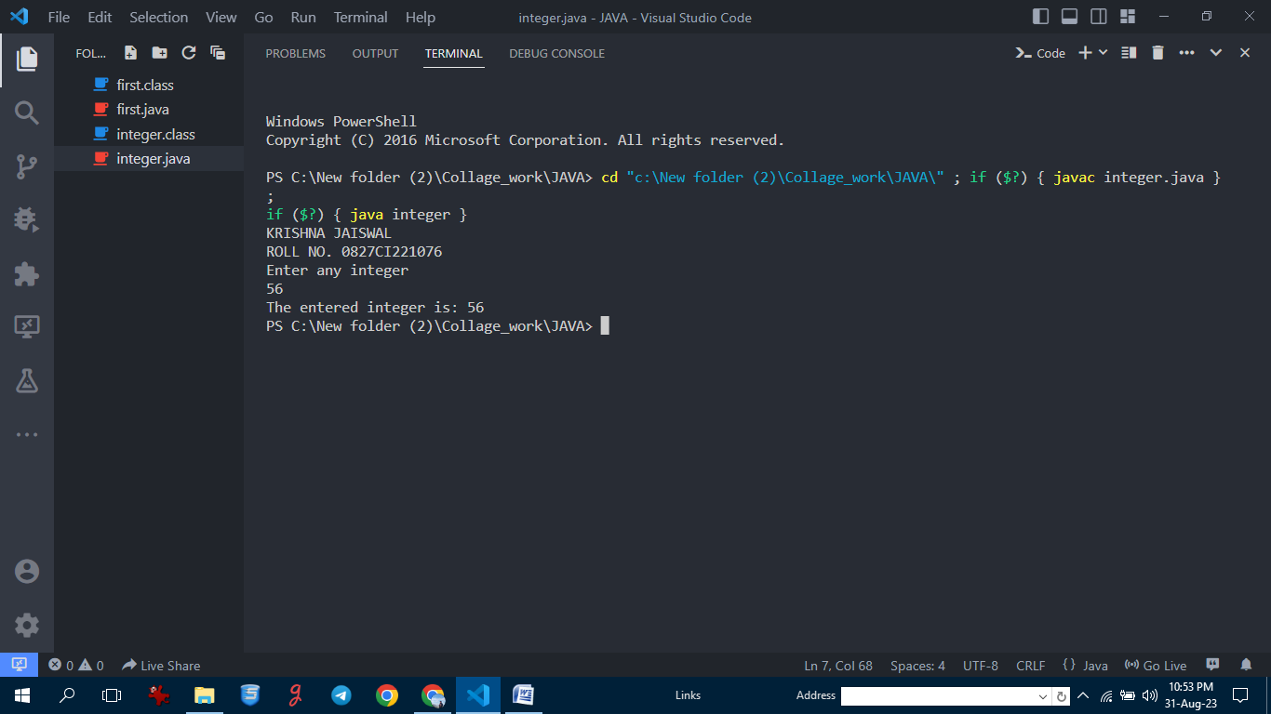

2. Write a program to demonstrate the usage of primitive data types—Boolean, char, byte, short, Int, long, float and double:-

public class all_opert {

    public static void main(String[] args) {

        System.out.println("\n KRISHNA JAISWAL\n ROLL NO. 0827CI221076");

*// Boolean data type*

        boolean isJavaFun = true;

        System.out.println("In Java boolean data types \n " + isJavaFun);

*// Char data type*

        char grade = 'A';

        System.out.println("\nMy grade is: " + grade);

*// Byte data type*

        byte byteValue = 127;

        System.out.println("\nByte value: " + byteValue);

*// Short data type*

        short shortValue = 32000;

        System.out.println("\nShort value: " + shortValue);

*// Int data type*

        int intValue = 123456;

        System.out.println("\nInt value: " + intValue);

*// Long data type*

        long longValue = 1234567890L;

        System.out.println("\nLong value: " + longValue);

*// Float data type*

        float floatValue = 3.14f;

        System.out.println("\nFloat value: " + floatValue);

*// Double data type*

        double doubleValue = 3.14159265359;

        System.out.println("\nDouble value: " + doubleValue);

    }

}

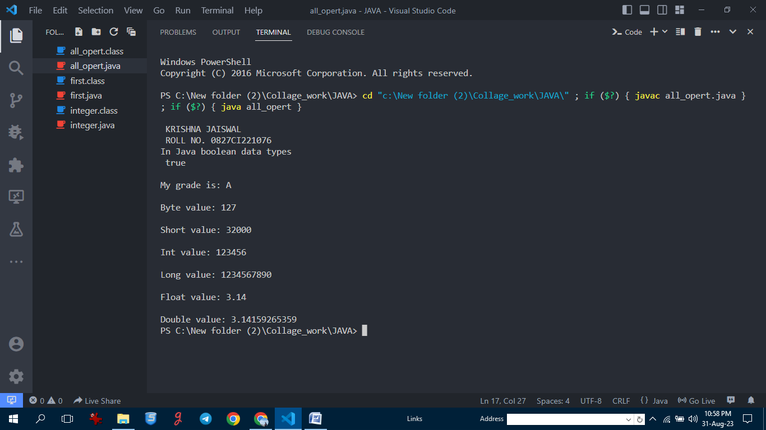

3. Swapping two numbers using temporary variable:-

import java.util.Scanner;

public class swap {

    public static void main(String args[]) {

        System.out.println("\n KRISHNA JAISWAL\n ROLL NO. 0827CI221076");

        Scanner sc = new Scanner(System.in);

        System.out.println("Enter the number 1  :");

        int a = sc.nextInt();

        System.out.println("Enter the number 2  :");

        int b = sc.nextInt();

        int tmp;

        tmp = a;

        a = b;

        b = tmp;

        System.out.println("The swapped numbers are:\n" + a + "\t" + "and" + "\t" + b);

    }

}

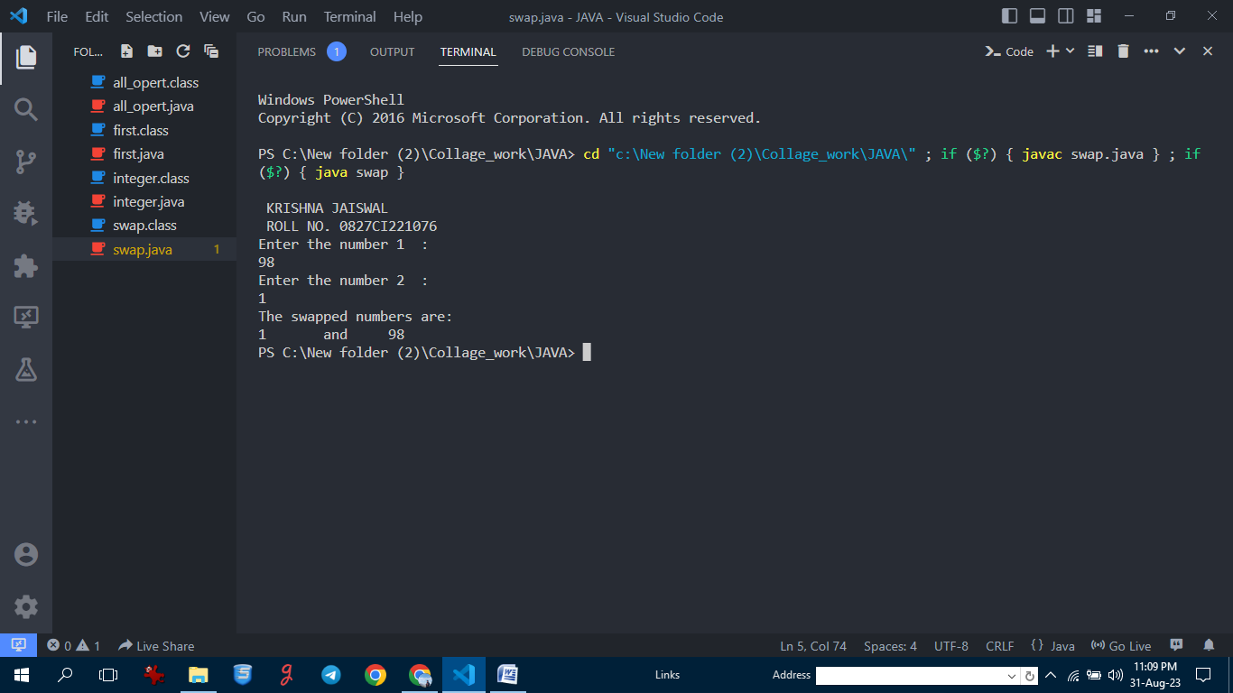

4.Check whether a number is even or odd using if..else statement:-

import java.util.Scanner;

public class even_od {

    public static void main(String args[]) {

        System.out.println("\n KRISHNA JAISWAL\n ROLL NO. 0827CI221076");

        System.out.println("Enter any number: ");

        Scanner sc = new Scanner(System.in);

        int num = sc.nextInt();

        if (num % 2 == 0) {

            System.out.println("The number [" + num + "] is even.");

        } else {

            System.out.println("The number [" + num + "] is odd");

        }

    }

}

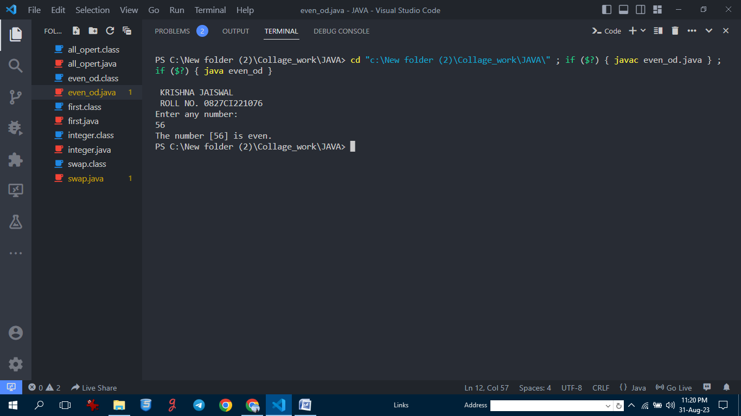

5. Check whether an alphabet is a vowel or a consonant using if…else statement:-

import java.util.Scanner;

public class vowel {

    public static void main(String args[]) {

        System.out.println("\n KRISHNA JAISWAL\n ROLL NO. 0827CI221076");

        System.out.println("Enter any alphabet: ");

        try (Scanner sc = new Scanner(System.in)) {

            char ch = sc.next().charAt(0);

            if (ch == 'a' || ch == 'e' || ch == 'i' || ch == 'o' || ch == 'u') {

                System.out.println("The entered alphabet [" + ch + "] is a vowel.");

            } else if (ch == 'A' || ch == 'E' || ch == 'I' || ch == 'O' || ch == 'U') {

                System.out.println("The entered alphabet [" + ch + "] is a vowel.");

            } else {

                System.out.println("The entered alphabet [" + ch + "] is aconsonant.");

            }

        }

    }

}

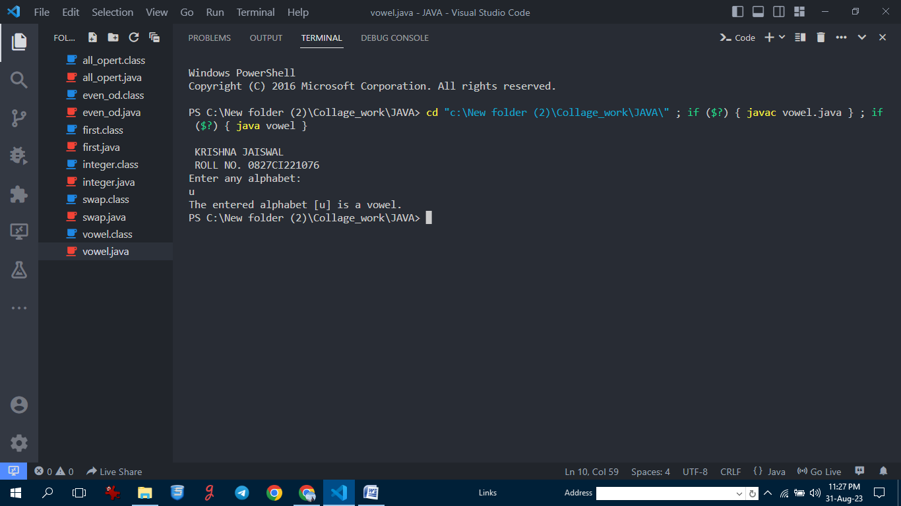

6. Check if a number is positive or negative using if..else.

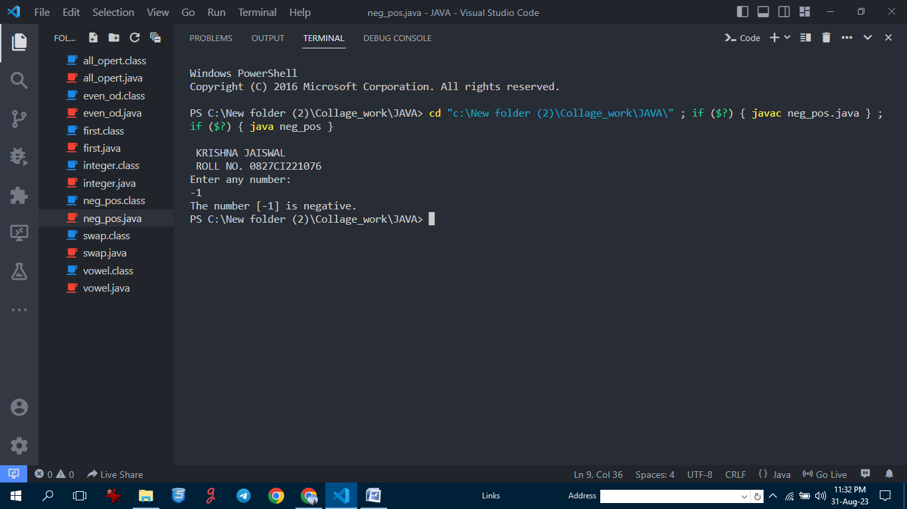

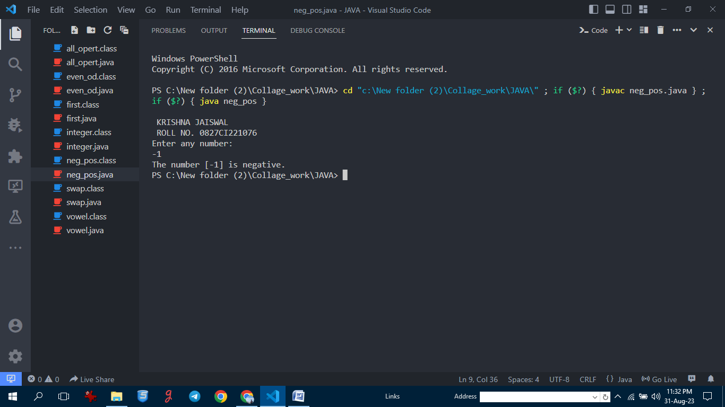

7. Sum of natural numbers using for loop:-

import java.util.Scanner;

public class sum_of_num {

    public static void main(String args[]) {

        System.out.println("\n KRISHNA JAISWAL\n ROLL NO. 0827CI221076");

        System.out.println("Enter number of terms: ");

        try (Scanner sc = new Scanner(System.in)) {

            int n = sc.nextInt();

            int sum = 0;

            for (int i = 0; i <= n; i++) {

                sum += i;

            }

            System.out.println("The sum is " + sum);

        }

    }

}

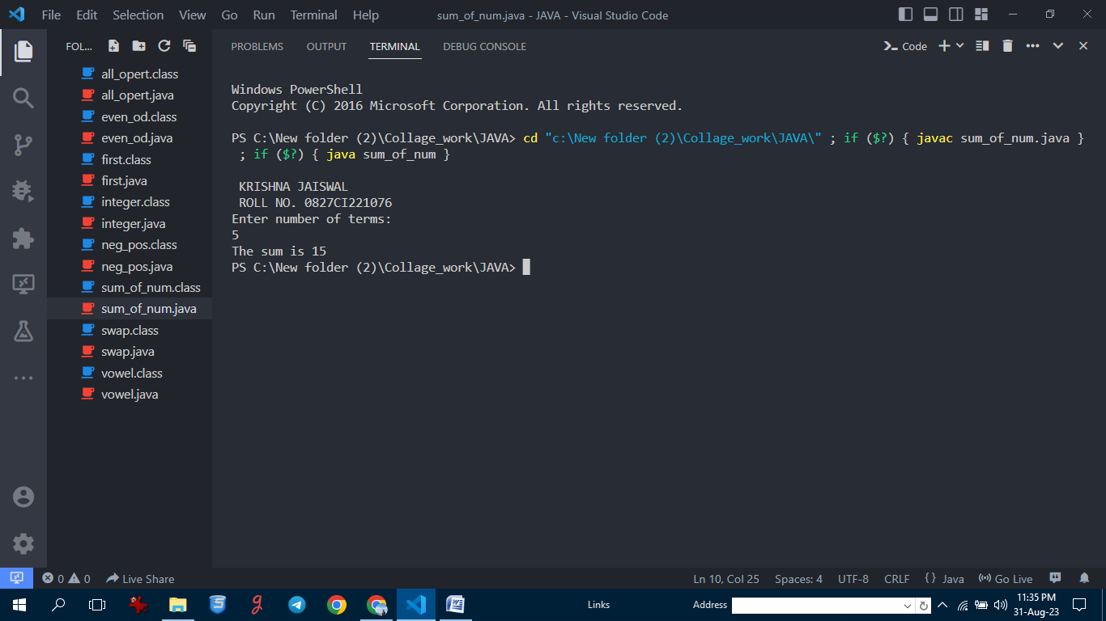

8. Find factorial of a number using for loop:- import java.util.Scanner;

public class factorial {

    public static void main(String args[]) {

        System.out.println("\n KRISHNA JAISWAL\n ROLL NO. 0827CI221076");

        System.out.println("Enter number of terms: ");

        try (Scanner sc = new Scanner(System.in)) {

            int n = sc.nextInt();

            int fact = 1;

            for (int i = 1; i <= n; i++) {

                fact *= i;

            }

            System.out.println("The factorial is " + fact);

        }

    }

}

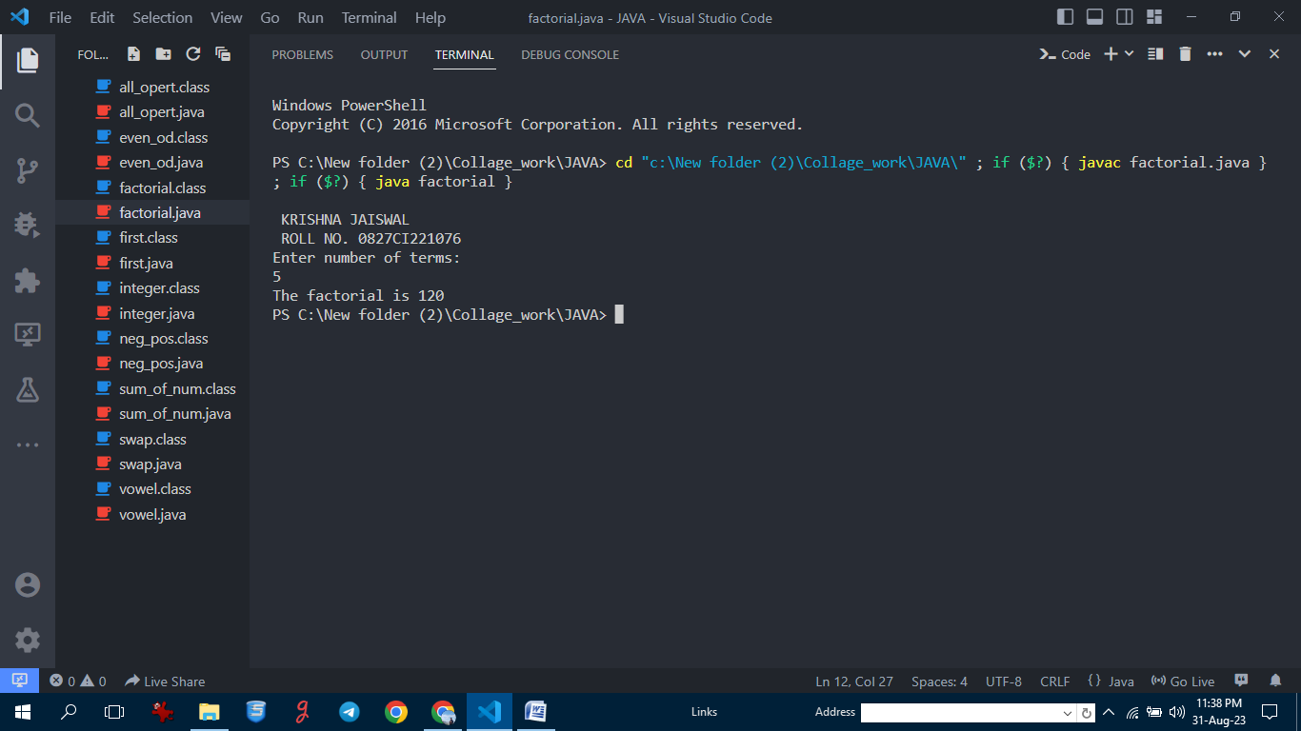

9. Generate multiplication table using for loop:-

import java.util.Scanner;

public class table {

    public static void main(String args[]) {

        System.out.println("\n KRISHNA JAISWAL\n ROLL NO. 0827CI221076");

        System.out.println("Enter the number whose table you want to print:");

        try (Scanner sc = new Scanner(System.in)) {

            int num = sc.nextInt();

            for (int i = 1; i <= 10; i++) {

                System.out.println(num + " " + "*" + " " + i + " " + "=" + num * i);

            }

        }

    }

}

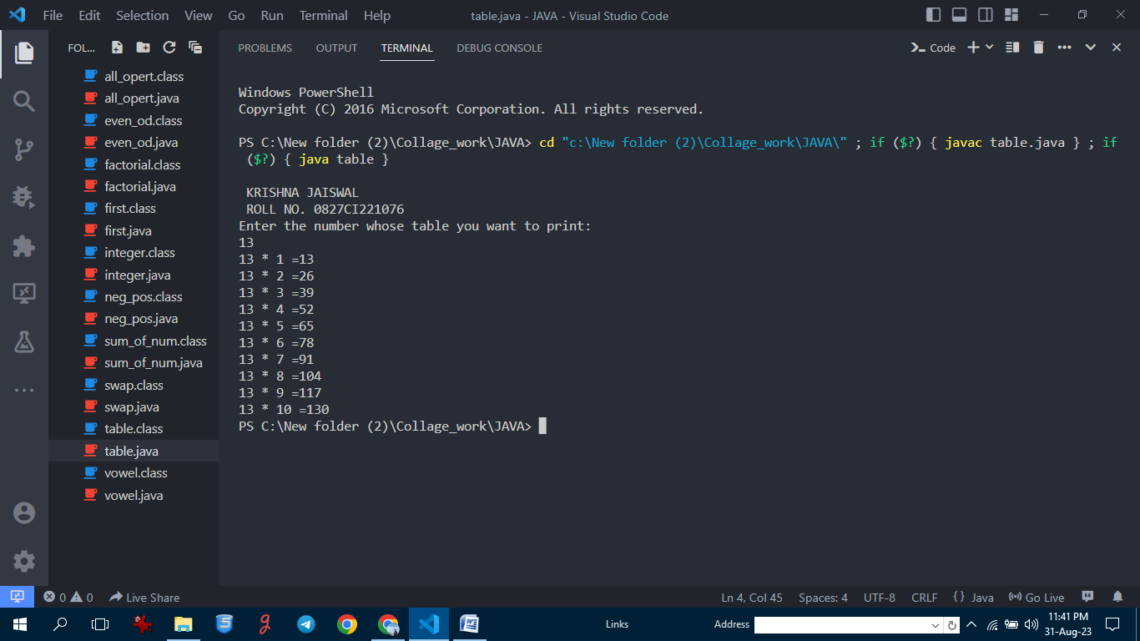

10. Display uppercased alphabet using for loop:-

public class a_z_alpha {

    public static void main(String args[]) {

        System.out.println("\n KRISHNA JAISWAL\n ROLL NO. 0827CI221076");

        System.out.println("The uppercased alphabets are:");

        for (char i = 'A'; i <= 'Z'; i++) {

            System.out.println(i);

        }

    }

}

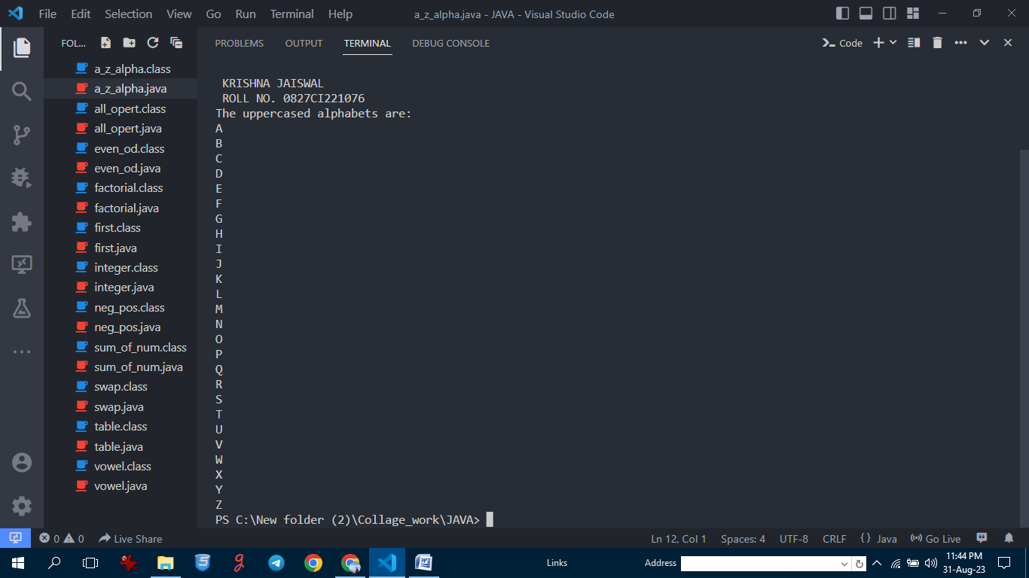

11. Find GCD of two numbers using for loop and if statement:-

import java.util.Scanner;

public class G_C_D {

    public static void main(String args[]) {

        System.out.println("\n KRISHNA JAISWAL\n ROLL NO. 0827CI221076");

        try (Scanner sc = new Scanner(System.in)) {

            System.out.println("Enter any two numbers 1 : ");

            int a = sc.nextInt();

            System.out.println("Enter any two numbers 2 : ");

            int b = sc.nextInt();

            int gcd = 1;

            for (int i = 1; i <= a && i <= b; i++) {

                if (a % i == 0 && b % i == 0) {

                    gcd = i;

                }

            }

            System.out.println("The GCD of the numbers is: " + gcd);

        }

    }

}

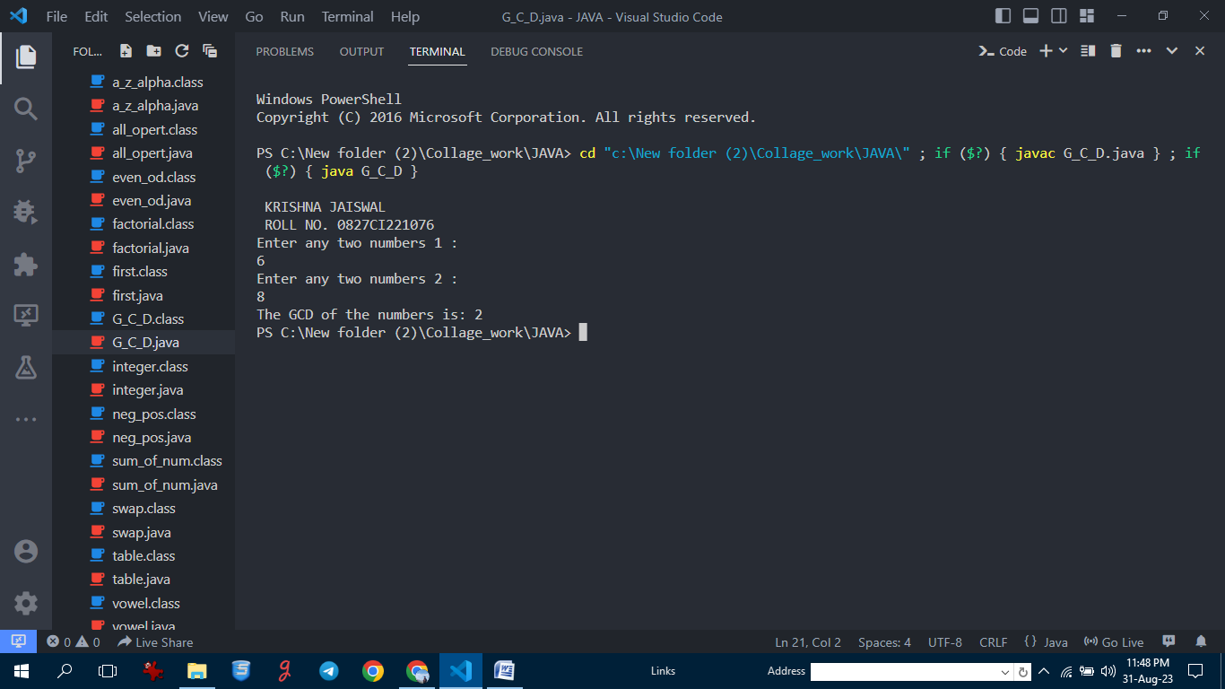

12. Program to find the reverse of a number:-

import java.util.Scanner;

public class revers_num {

    public static void main(String args[]) {

        System.out.println("\n KRISHNA JAISWAL\n ROLL NO. 0827CI221076");

        System.out.println("Enter any number: ");

        try (Scanner sc = new Scanner(System.in)) {

            int n = sc.nextInt();

            int rev = 0;

            while (n > 0) {

                int a = n % 10;

                n = n / 10;

                rev = (rev * 10) + a;

            }

            System.out.println("The reversed number is: " + rev);

        }

    }

}

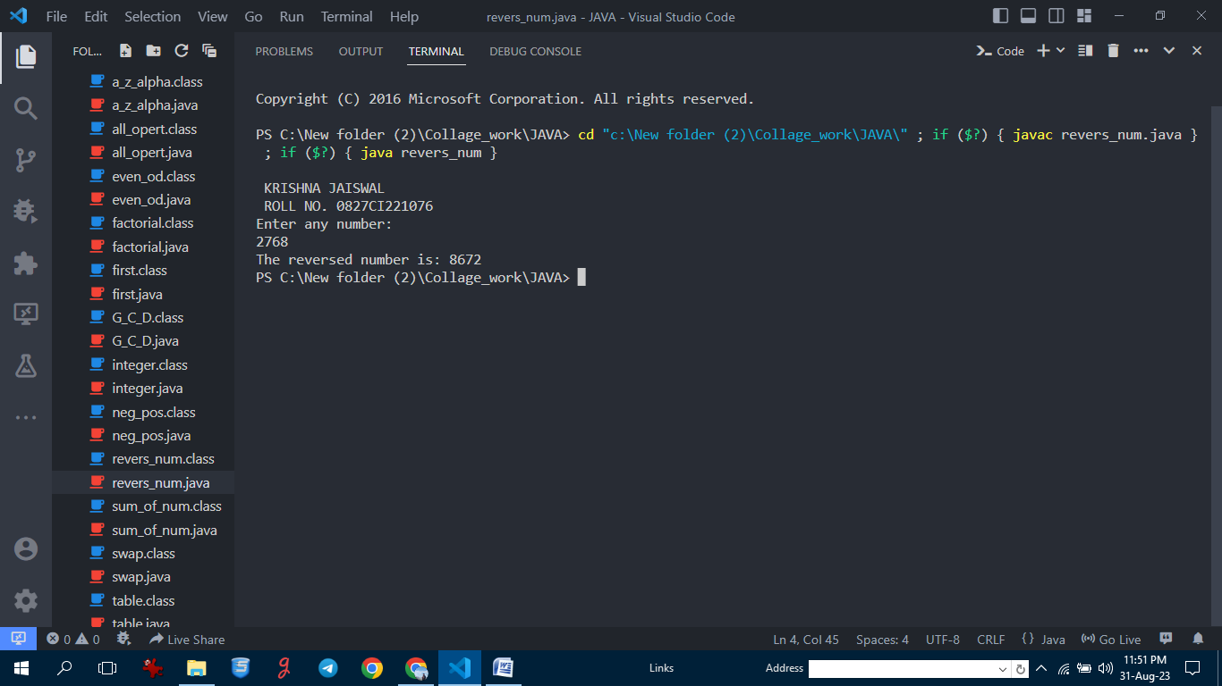

13.Demonstrate creating a class and Instance(object)

*// Java Program for class example*

class Student {

*// data member (also instance variable)*

    int id;

*// data member (also instance variable)*

    String name;

    public static void main(String args[]) {

        System.out.println("\n KRISHNA JAISWAL\n ROLL NO. 0827CI221076");

*// creating an object of*

*// Student*

        Student s1 = new Student();

        System.out.println(s1.id);

        System.out.println(s1.name);

    }

}

14.Demonstrate using Instance/class Variable in a Java Program by creating a simple public class

public class instance_class

{

*/* declaration of instance variables. */*

    public String name; *// public instance*

    String division; *// default instance*

    private int age; *// private instance*

*/* Constructor that initialize an instance variable. */*

    public instance_class(String sname) {

        System.out.println("\n KRISHNA JAISWAL\n ROLL NO. 0827CI221076");

        name = sname;

    }

*/* Method to intialize an instance variable. */*

    public void setDiv(String sdiv) {

        division = sdiv;

    }

*/* Method to intialize an instance variable. */*

    public void setAge(int sage) {

        age = sage;

    }

*/* Method to display the values of instance variables. */*

    public void printstud() {

        System.out.println("Student Name: " + name);

        System.out.println("Student Division: " + division);

        System.out.println("Student Age: " + age);

    }

*/* Driver Code */*

    public static void main(String args[]) {

        instance_class s = new instance_class("KRISHNA JAISWAL. ");

        s.setAge(14);

        s.setDiv("B");

        s.printstud();

    }

}

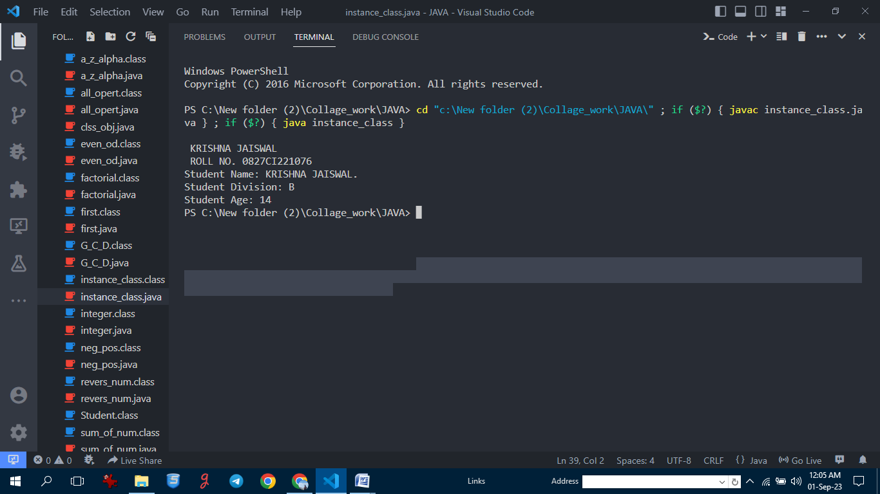

1. Demonstrate the java class using getter setter method for accessing private data members
2. public class GetterSetterExample {
3. private String name; *// private = restricted access*
4. *// System.out.println("\n KRISHNA JAISWAL\n ROLL NO. 0827CI221076");*
5. *// Getter*
6. public String getName() {
7. return name;
8. }
9. *// Setter*
10. public void setName(String newName) {
11. this.name = newName;
12. }
13. }

16. Demonstrate the use of static variable

*// Java program to demonstrate execution*

*// of static blocks and variables*

class Test {

*// static variable*

    static int a = m1();

*// static block*

    static {

        System.out.println("\n KRISHNA JAISWAL\n ROLL NO. 0827CI221076");

        System.out.println("Inside static block");

    }

*// static method*

    static int m1() {

        System.out.println("from m1");

        return 20;

    }

*// static method(main !!)*

    public static void main(String[] args) {

        System.out.println("Value of a : " + a);

        System.out.println("from main");

    }

}

1. Demonstrate the use of Scanner class for taking input/output from user:-
2. import java.util.Scanner;
3. public class input_output {
4. public static void main(String args[]) {
5. System.out.println("\n KRISHNA JAISWAL\n ROLL NO. 0827CI221076");
6. System.out.println("Enter any number: ");
7. try (Scanner sc = new Scanner(System.in)) {
8. int n = sc.nextInt();
9. System.out.println(n);
10. }
11. }
12. }

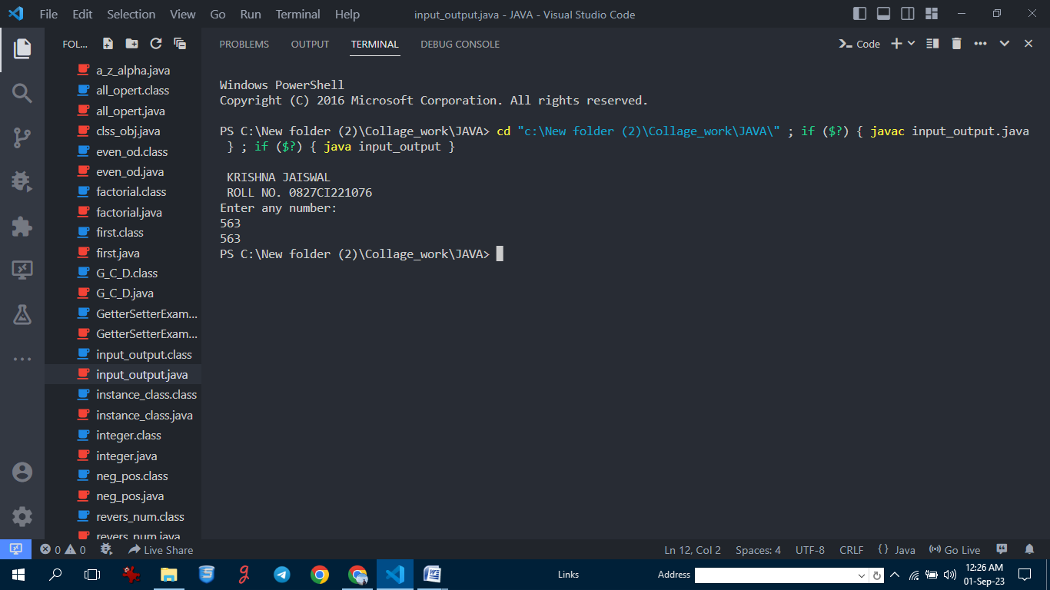

19. Light program:-

import java.util.Scanner;

public class Light {

    boolean isOn;

    void switchOn() {

        isOn = true;

        System.out.println(isOn);

    }

    void switchOff() {

        isOn = false;

        System.out.println(isOn);

    }

    public static void main(String args[]) {

        System.out.println("\n KRISHNA JAISWAL\n ROLL NO. 0827CI221076");

        Light led = new Light();

        Light halogen = new Light();

        led.switchOn();

        halogen.switchOff();

        System.out.println(led.isOn);

    }

}

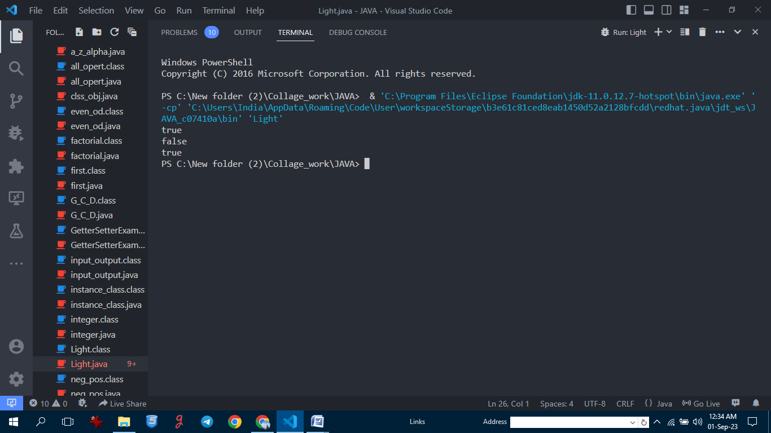

20. Box Program:-

public class Box {

    private int height;

    private int length;

    private int breadth;

    Box() {

        height = 0;

        length = 0;

        breadth = 0;

    }

    Box(int height, int length, int breadth) {

        this.height = height;

        this.length = length;

        this.breadth = breadth;

    }

    public int Volume() {

        return (length * breadth * height);

    }

    public static void main(String args[]) {

        Box cuboid1 = new Box();

        System.out.println("The area of the cuboid is" +

                cuboid1.Volume());

        Box cuboid2 = new Box(10, 15, 30);

        System.out.println("The area of cuboid is" +

                cuboid2.Volume());

    }

}

